FunBankApp - Software Requirements Specification (SRS)

Page 1: Title Page
Project Name: FunBankApp
Team Members: Jarom Brads (Solo Developer)
Project Description:
FunBankApp is a secure, behaviorally-aware financial calculator designed for everyday users. It leverages user-submitted financial data and the Ollama API to deliver personalized summaries and basic investment advice via a chatbot interface. The application is being built with Spring Boot and hosted on a local SQL server, with plans for AWS deployment.

Section 1: Introduction
Purpose:
FunBankApp aims to provide users with an intelligent, simplified view of their financial situation, offering helpful behavioral nudges via Ollama to promote smarter financial decisions.
Scope:
The MVP includes secure user login, financial data input, and automated calculation of retirement estimates. I would like to include chatbot integration using Ollama as a requirement, but it does not seem possible in the current timeline. In order to include Ollama, I might move away from the API’s provide the service client side to focus less on the Cloud aspect. Frontend development, cryptocurrency integration, and cloud deployment are stretch goals.
Overview:
Users register, input their financial information, and receive a retirement income estimate and basic behavioral advice. Information is encrypted and stored securely, and recommendations are presented through a chatbot.
User Profiles:
Everyday users interested in budgeting, retirement planning, or learning about financial wellness.
Workflows:
- User registers and logs in.
- Inputs financial data.
- System computes retirement projections.
- Ollama responds with human-like financial advice.
- The user clicks continue chatting and is then led to a chatbot window to receive advice based on their financial statements.
Standards:
- Coding: Follows RESTful standards.
- Design: Based on modular Spring Boot services.
- Learning Model: Ollama API integration (GPT).
- Architecture: Microservice-based with potential for client-side data hosting. Right now it is hosted on a local SQL server, but I would need to move that into the cloud for users to use it, so to keep costs down, I am planning on moving toward client-side data housing in JSON files. Another reason for this is I have found Ollama works well with JSON as compared to other data structures.
- Quality Assurance: Unit tests, integration tests, Postman testing(For API’s currently – might move away from Postman).
- Legal & Security Risks: Passwords encrypted via BCrypt. JWT for secure sessions. No production-level compliance (yet). As this is a test financial product, I need to do more research to find out if I need to do anything to be totally compliant with financial rules.

Section 2a: Requirements
- The system shall allow users to register and log in securely.
  - Success Measurement: Users can authenticate with valid credentials. Passwords are stored encrypted.
- The system shall allow users to input and store financial account data.
  - Success Measurement: Financial inputs are validated, saved to the database, and retrievable.
- The system shall generate a retirement income estimate based on user input.
  - Success Measurement: Application computes projections without errors and provides results in real-time.
- The system shall encrypt all personally identifiable information (PII).
  - Success Measurement: Confirm encrypted storage of passwords and sensitive fields in the DB. If I do this as a microservice, I do not know if I need them to login or if I should save any information.

Section 2b: Stretch Requirements
- The system will provide behavioral financial advice via Ollama to support users in volatile markets.
- The system could integrate cryptocurrency wallets for complete financial overview.
- The system should offer financial planning recommendations using a chatbot interface.
- The system would store user data locally if operating in standalone mode, removing AWS dependency.

Section 3: Design Overview
Workflow:
- Register/Login
- Enter income, savings, debts, and retirement goals.
- API calls calculate estimates.
- Ollama chatbot returns a narrative summary and advice.
Resources:
- Backend: Spring Boot
- Database: MySQL (JDBC) Possibly future (client side JSON)
- Deployment: Local, future AWS (RDS, EC2) Possibly future (client side JSON)
- Auth: Spring Security, JWT, BCrypt
- AI: Ollama API
3rd Party Libraries:
- Spring Boot, Lombok, MySQL Connector, Swagger, JWT, SpringDoc
Architecture/Tiers:
- Microservice Backend
- (Planned) Frontend Tier (HTML/React or simple Tailwind/CSS) I am really bad at design, so how good this looks will be a good measure of how successful I think it is.
Data at Rest:
- Stored in MySQL: hashed passwords, financial inputs.
Data on the Wire:
- JSON over HTTPS, JWT for session validation. Right now, I am using JWT, but I might switch to data client-side held with JSON
Data State Flow Diagram:
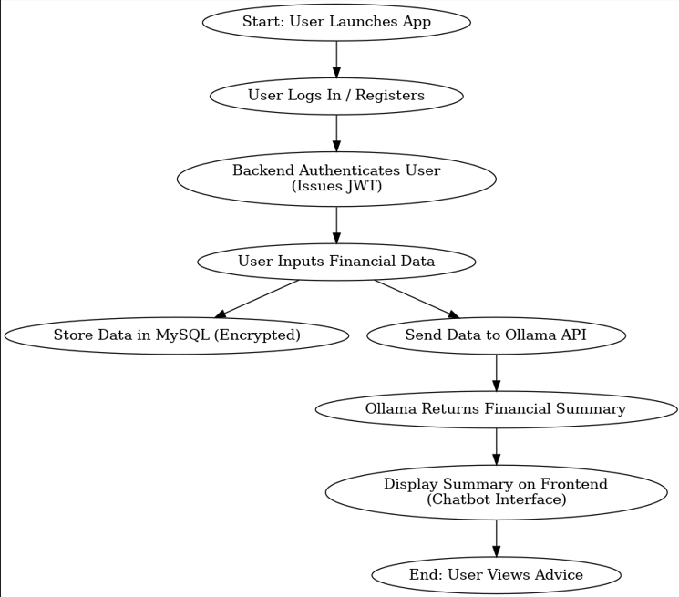
As mentioned, data might change to JSON so I can focus on more cool features (ollama and crypto)
HMI/HCI/GUI:
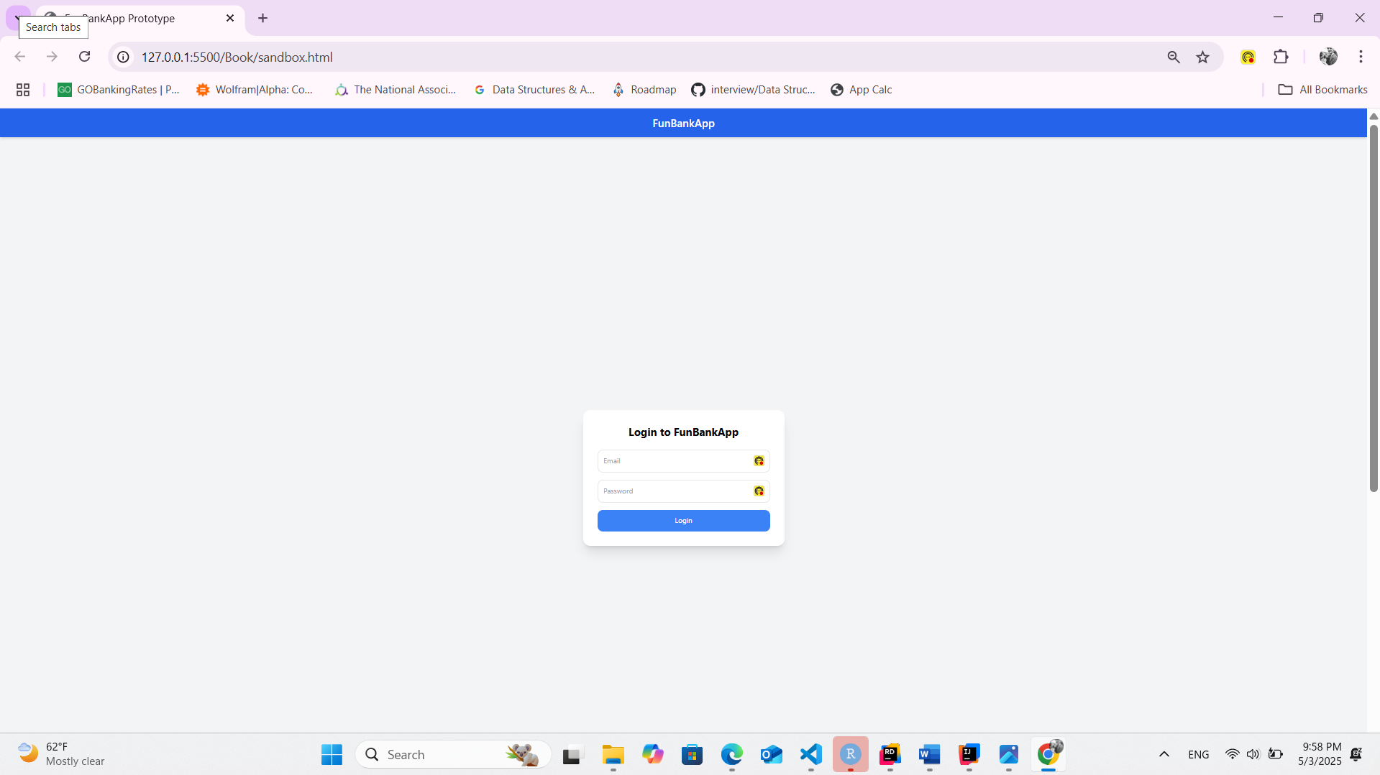
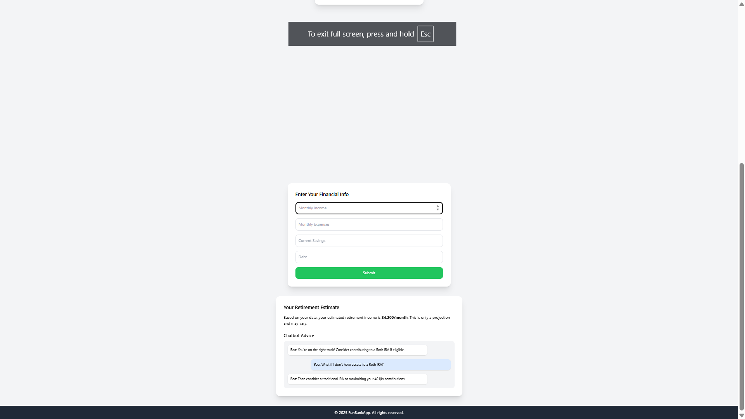
I still don’t have a mvp for the chatbot area yet, as there is more I need to do, but here is a sandbox.html I made with a idea of how I want key parts to look.
Section 4: Verification
Demo Plan:
- Show login/registration flow
- Submit example financial profile
- Display retirement estimate and chatbot feedback
Here are some examples of tests, I am already done with, even though I might switch from AWS to JSON
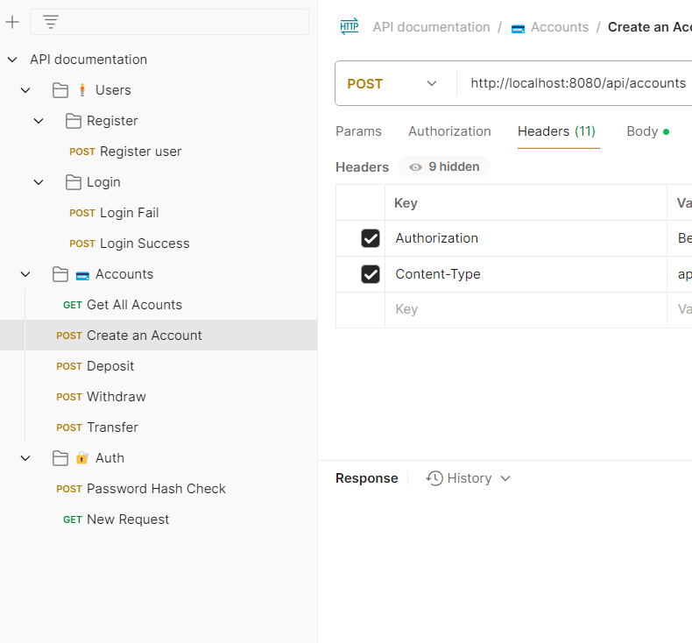
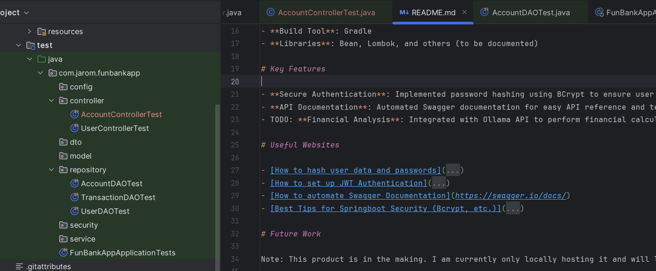
Testing:
- Unit tests using Spring Test Suite & Mockito
- Postman for manual API checks
- Security validation through JWT and BCrypt

Sources / Citations / Resources
- Spring Security Password Encoding with BCrypt
- Spring Boot JWT Authentication
- Swagger/OpenAPI Setup
- Spring Security Best Practices GitHub
- Software Demo Video

